Aliyeva Khadija (2026). Phase Change Materials for Improving Thermal Energy Storage and Energy Efficiency in Buildings: Literature-Based Project. Unpublished project, Baku.
Abstract
PCM (phase change material) are materials undergo a phase change when certain temperature is reached, accumulate heat in the form of latent heat and then solidify, release heat as the temperature decreases. PCM’s properties such as storing latent heat, effectively regulating temperature, resistance to thermal cycles and low thermal conductivity allow it to be widely applied in buildings. This article summarizes the work of researches who have studied integration of PCMs into buildings. The areas of PCM types, Impregnation of PCMs into construction materials, Use of PCMs in Building Construction are covered.
1.Introduction
Energy consumption in the world is constantly increasing rapidly. The main source of this increase is mainly related to economic development, population growth and higher living standards. Fossil fuels still remain the main source of energy production. However, their use as fuel increases the amount of CO2 emissions. Although global energy consumption is increasing every day, this growth rate has slowed down somewhat in recent years and is an average of about 1-2% per year. The widespread use of electric cars, heat pumps, air conditioners and electrolyzes has led to an increase demand for electricity in particular. It is important to monitor global energy consumption and find ways to use it more efficiently. (1) The building sector i.e. the energy used to build new homes, workplaces and for heating, cooling and lightning accounts for more than a third of global energy consumption and emissions. Thus, the operation of building accounts for 30% of final energy consumption and 26% of global energy emissions. (5)
Energy efficiency offers the fastest and most cost-effective way to reduce CO2 emissions. Energy efficiency plays a key role in reducing energy demand in the Net Zero scenario by 2050. Through these measures, it reduces the amount of energy required to produce one unit of GDP. Improvements in energy intensity over the past 20 years have contributed to a significant reduction in CO2 emissions. (2) Thermal energy storage is a viable way to increase energy efficiency and save energy. (3)
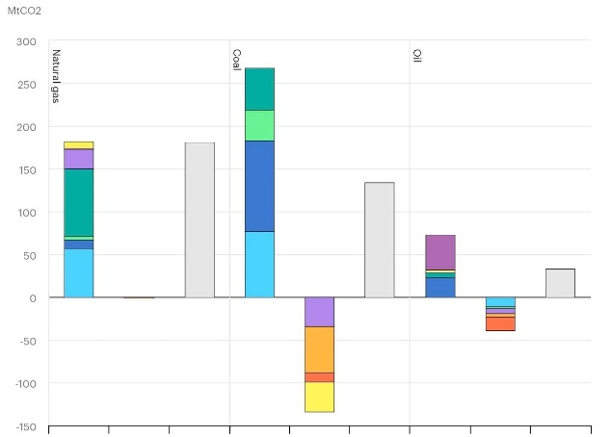
Figure 1. CO2 emissions from fuel combustion by region (according to [15]
TES is one of the energy storage technologies. It involves methods to make thermal energy available for use after it has been produced. There are three main principles of thermal energy storage:
SHS, LHS, TCS
Sensible Heat Storage.
SHS uses a liquid or solid storage material to store and release heat energy. The working principle is based on increasing or decreasing the temperature of the storage material. (e.g., water, sand, molten salts, graphite, rocks, with water being the cheapest option). SHS is the most common way to store heat energy, widely used in both industry and domestic applications. The energy storage temperature varies from 0-2400$°$C
Thermochemical Heat Storage
TCS works through two mechanisms: chemical reactions and sorption processes. TCS can store heat energy in the range of 0-900$℃$ for hours, days or even months.
Latent Heat Storage.
The LHS principle uses phase change materials. As the PCM absorbs heat energy, it absorbs and stores it and the temperature of the material doesn’t change. During the off-peak, the PCM reaches its melting point and even if material receives more heat, the temperature doesn’t change, the energy is spent on the phase transformation. This is the time when energy is stored. During the peak, the PCM begins to solidify. The energy stored by material is released back and the temperature remains approximately constant. This is the time when energy is used. With this method, thermal energy can be stored in the range of 0-1600$°C$for hours to days. (4)
Global energy demand is increasing rapidly, especially in buildings. Heating and cooling in buildings both increases energy costs and carbon emissions. Therefore, it is very important to increase energy efficiency in buildings as well as to store thermal energy. PCMs are widely used to solve this problem, as they can absorb and store energy and release it when needed. The main objective of the study is to evaluate the potential of PCMs to store thermal energy in buildings and improve energy efficiency. (1)
2. Classification of PCMs
Numerous compounds are used as PCMs due to their diverse physical and chemical properties. Solid-liquid PCMs also have the ability to absorb and release large amounts of latent heat over a wide temperature range. (6) PCMs are incorporated into materials such as walls, floors, ceilings and construction mortars. Thus, they are particularly suitable for use in buildings, as they have the ability to store heat accumulated in buildings during the day and release it at night.
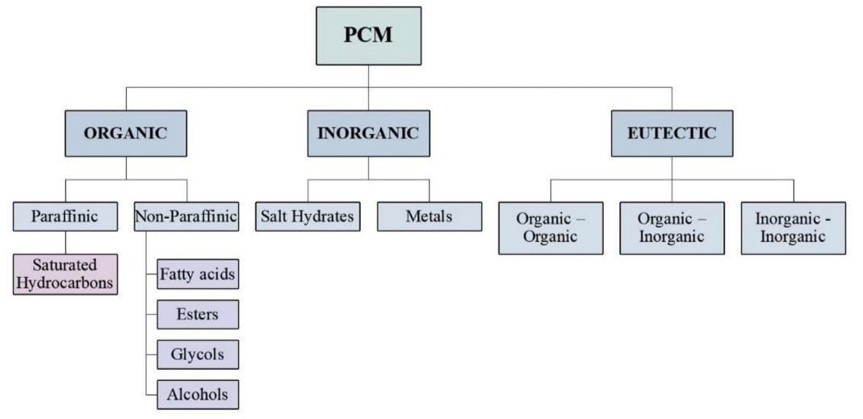
Figure 2. Classification of PCM materials (according to [6]).
2.1 Organic Materials.
Organic PCMs can be paraffinic or non- paraffinic. Paraffin waxes, which are widely used in buildings, are the most common organic PCM of the paraffin type. Non-paraffinic PCMs include fatty acids, fatty acid esters, glycolic acids, alcohols etc. The structure of Paraffinic PCMs consists of a chain combination of C and H atoms.
Non-Paraffinic PCMs contain electronegative (O, N etc.) atoms in addition to C and H atoms. Paraffin waxes have a hydrocarbon chain of 8-15 carbons, while pure paraffin has a hydrocarbon chain of 14-10 carbons. (3) The length of carbon chain directly affects the thermal properties of the material. Thus, paraffin waxes are soft and waxy with a lower melting point. However, pure paraffin has a higher melting point and a more stable phase change.
Non-Paraffinic PCMs are made from bio-based raw materials such as animal fats and vegetable oils (beef fat, margarine, castor oil etc.). They are biodegradable, renewable and non-toxic materials. Although non-paraffinic PCMs have superior environmental properties, they are more corrosive and expensive than Paraffinic PCMs. (3)
Advantages of Organic PCMs.
These materials maintain a constant temperature during melting and freezing and they show a very low degree of supercooling. They are chemically inert, non-reactive compounds, which means they don’t decompose or lose their properties during use. In addition, they are suitable for long-term use because they don’t cause phase separation problems. One of the most important advantages of Organic PCMs is their compatibility with traditional construction materials, which makes them easy to incorporate into building materials such as concentrate, mortar, roofing etc. (3,7)
Disadvantages of Organic PCMs
One of the main disadvantages is that in the solid phase (frozen state) the heat energy is transferred to the environment slowly. Studies have shown that the addition of nanoparticles to PCMs can overcome this problem. These nanoparticles help to spread heat rapidly through the material by creating thermal bridges within PCMs. As a result, the thermal conductivity of PCMs in the solid phase increases and the heat transfer during freezing/thawing is accelerated. (7)
2.2 Inorganic Materials
There are two main types of inorganic compounds that can be used as PCMs: hydrated salts and metals. Hydrated salts are salts that contain a certain number of water molecules (H2O).
Their general formula is ABH2O. In hydrated salts, the phase change occurs through a dehydration rection, unlike ordinary melting. That is, thermal energy is stored or transferred by breaking and forming salt-water bonds. Thus, when the ambient temperature is high, a large amount of heat is absorbed as a result of the hydrated salt releasing water molecules. When the temperature decreases, the water molecules re-enter the salt structure and the stored heat is transferred back.
The group of metals includes metals with low melting points and their eutectic mixtures. These materials have favorable properties such as their eutectic mixtures. However, they have been studied to a limited extent because they aren’t practical for heavier construction. (3)
Inorganic PCMs have a number of important properties. These materials have a high latent heat storage capacity per volume. The high melting point of inorganic PCMs allows them to be used in a wider temperature range. Inorganic PCMs also have high thermal conductivity and this property is higher than organic PCMs due to their crystalline and iconic structure.
However, they also have disadvantages. Many inorganic PCMs, especially hydrated salts, can exhibit incongruent melting problems. During this process, phase separation occurs, so that the PCMs are no longer a homogeneous material but rather separate parts are formed. As a result, during the charging and discharging cycle, they no longer consist of a homogenous phase, which reduces their performance. In addition, many inorganic PCMs especially hydrated salts, can damage metals and they are sometimes hazardous and have limited compatibility with construction materials.
2.3 Eutectic Mixtures.
Eutectic Mixtures are obtained by mixing two or more compounds of PCMs, either organic or inorganic, or both. By varying the type and ratio of compounds, PCMs with very different properties can be obtained. (3) Organic Eutectic PCMs are more stable than inorganic or inorganic/organic mixtures because they don’t lose their phase transition temperature and heat storage capacity after the melting-solidification cycle. They also have high phase transition enthalpies and easy absorption into porous carrier materials. Despite all these advantages, the production of Organic Eutectic PCMs is expensive due to high cost of raw materials and processing. They also have the disadvantage of having strong odor. (3,7)
3. Properties of PCMs
There are many types of PCMs. Since each of the available PCMs has different properties, each appropriate candidate must be carefully evaluated when selecting PCMs. Important parameters to consider during selection include phase transition temperature, latent heat value, thermal conductivity and compatibility with building materials. These properties determine the effectiveness of PCMs and each material has advantages and disadvantages. When selecting PCMs to be used in buildings to store thermal energy and increase energy efficiency it isn’t possible to find all the ideal properties in a single material. For example, when selecting material with high latent heat and good thermal conductivity it maybe expensive but certain compromises can be made because its compatibility with buildings saves energy effectively. (3)
4. Construction materials modified with PCMs
4.1 Traditional methods
According to Hawes et al., the three most suitable methods for incorporating PCMs into traditional construction materials are direct incorporation immersion and macrencapsulation.
1. Direct incorporation
This is the simplest method. PCMs in liquid or powder form are directly added during the production of construction materials such as plaster, concrete, brick, etc. This method doesn’t require additional equipment. During this method, problems and incompatibility of PCMs with construction materials can be encountered.
2. Immersion
In this method, building materials such as concrete, bricks are first immersed in molten PCM.
The PCM is attracted to the internal pores and voids of the material through capillary force and the PCM is then absorbed into the internal pores of the material. According to the researchers, this method can cause leakage problem for long-term use.
3. Macroencapsulation
The technology in which PCMs are stored in a container (tubes, spheres or panels) and don’t come into contact with the building materials is called Macroencapsulation.
Macroencapsulated PCMs can also eliminate the problem of leakage and the impact on the building materials is minimal. However, this method has disadvantages such as low thermal conductivity and difficulty in applying to building materials. (9)
4.2 Microencapsulation.
Microencapsulated PCMs are widely used for thermal energy storage in buildings. The PCMs are in the form of very small particles and each particle is coated with a thin, sealed layer of high molecular weight polymer. The polymer coating keeps the PCMs contained when they melt or solidify, which means that they maintain their shape during phase changes and prevent leakage of the material. Microencapsulated PCMs are easy to incorporate into building materials and are considered cost-effective. However, further studies are needed to determine the safety of microencapsulated PCMs, such as fire resistance. National Gypsum has produced wall panels using Microencapsulated PCM, manufactured by BASF. These panels are called Gypsum ThermalCORE Panels (Figure 3)
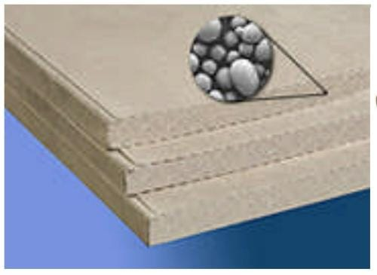(a)
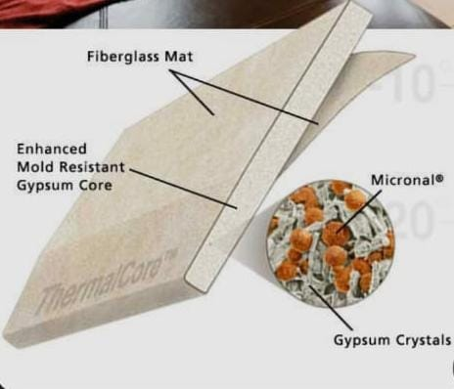(b)
Figure 3
(a) Gypsum wall panel with embedded Micronal PCM from BASF (according to [9]).
(b) National Gypsum ThermalCORE phase change drywall (according to [13]).
4.3 Shape-stabilized PCMs
In this method, PCM isn’t used separately, but distributed within another carrier material (e.g., a polymer-based carrier) to produce a stable composite material. (Figure 4) This type of PCM has the characteristics of high specific heat capacity, suitable thermal conductivity, ability to maintain its shape during phase change, resistance to repeated melting and cooling processes over a long period of time and high performance without losing its properties. (Figure 5)
Shape-stabilized PCMs were studied by Zhang and colleagues. It was found that since the PCM is already fixed in the carrier material, additional encapsulated containers for storing PCMs aren’t needed when using these materials. This simplifies the technical structure of the device for thermal energy storage. Due to these advantages, they proposed the application of PCMs as interior cladding in high-energy buildings, such as interior walls, ceilings and floors. (9)

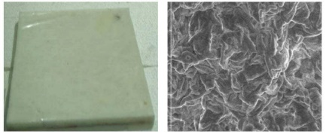
Figure 4 Shape-stabilized PCM plate for thermal energy storage (according to [9])
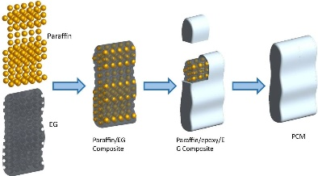
Figure 5 Fabrication of paraffin/EG composite PCM (according to [14])
5.Use of PCMs in Building Construction
In modern times, PCM technologies and their potential for application in buildings for the purpose of storing thermal energy have been widely investigated. The system in which PCM is applied for storing thermal energy is divided into 2 parts: active and passive systems
Active application systems require mechanical equipment or an additional energy source to operate. In these systems, in addition to faster and more efficient heat transfer to the PCM, temperature control is also easy. Active PCM systems include heating, ventilation and air conditioning systems (HVAC systems), systems operating with air or water circulation and storage tanks located outside the building.
Passive application systems don’t require additional energy or mechanical energy to operate. The main purpose of passive application systems is to increase the thermal performance of building structures. (3)
5.1 Use of PCMs in Wall Structures
One of the most effective ways to save energy in buildings is to incorporate PCMs into walls.
PCMs can be applied to the interior or exterior surfaces of walls. Example of materials for incorporating PCMs include mortars, gypsum boards, concrete blocks, bricks and panels.
Mortars and Plasters
Mortars and Plasters are widely used as coating materials on the surface of buildings, so they are good materials for application of PCMs. Depending on the binder components, there are many types of mortars: gypsum, lime, cement-based mortars. Cunha and colleagues investigated the properties of both encapsulated and unencapsulated into mortars and plasters. According to the studies, the addition of unencapsulated PCMs to the mortar doesn’t significantly increases their ability to store thermal energy.
Cyntia Guardia and colleagues investigated how encapsulated PCMs changed their properties by incorporating them into cement-based mortars. The results of studies showed that, when PCM was added to the mortar at a concentration of 10-20%, along with significant increase in the thermal energy storage capacity, a decrease in mechanical properties was observed within the permissible limit.
Gypsum Boards
Another product incorporating PCMs is gypsum boards, which are widely used in the construction industry due to their low cost. Srinivasaraonaik et al. investigated the incorporation of microencapsulated PCMs into gypsum mixture. It was found that the thermal conductivity of the gypsum composite, which helps to effectively store thermal energy within the gypsum.
Concrete Blocks and Bricks
Vinh Duy Cao conducted studies by incorporating microencapsulated PCMs into Portland cement and geopolymer concrete. It was found that the latent heat capacity increased, the thermal conductivity and the strengthening properties of the concrete or cement decreased in accordance with the concentration of added PCM.
The incorporation of PCMs into bricks was also investigated. According to study by Rajat Saxena et al., bricks incorporating PCMs reduced the temperature fluctuation in the room by 4,5$℃$ to 7$℃$. (3)
PCM Panels and Wallboards.
Panels and Wallboards, which are made by incorporating PCMs into traditional building materials are considered an effective method for retaining solar heat in buildings. In these systems, PCM gypsum boards are embedded in plaster or other building materials. (Figure 6) The thermal properties of PCM Wallboards are very close to those of PCM. As a result of the diffusion process, PCM isn’t evenly distributed within the board. PCM usually accumulates near the surface, which is the part that is in direct contact with the room air. (9,3)
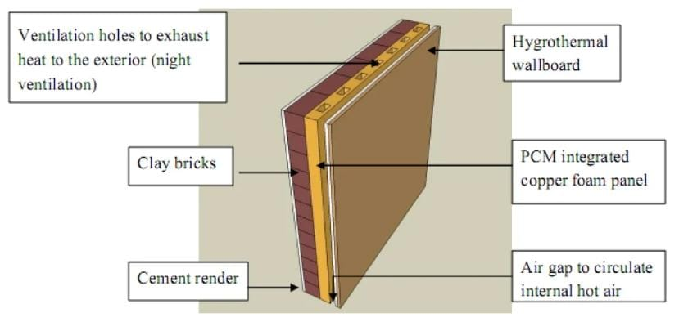
Figure 6. Wall structure featuring copper-foam embedded PCM panels (according to [13])
5.2 Use of PCMs in Floor and Ceiling Structures
Another area where PCM technologies are used for energy saving is in building floors. PCMs can be applied in various ways. PCMs can be incorporated into the structure by creating a single layer or multiplayer layers consisting of different types of PCMs. In addition, PCMs can be used in panels with capillary channels to dissipate heat more efficiently or in conjunction with an electrically powered system to reduce heat loss. Pasupathy and Velraj investigated the placement and thickness of PCM panels on the roof. As a result of study, it is advantageous to incorporate a double layer of PCMs into the roof structure to reduce large variations in room temperature during the day or during seasonal changes. (9,3)
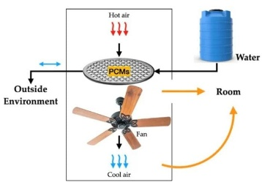
Figure 7. Ceiling fan incorporating PCM for cooling (according to [12])
5.3 Use of PCMs in Shutter Structures
The application of PCMs to blinds has been investigated. According to the Methling study, PCM integrated blinds can delay the maximum shading temperature by 3 hours and reduce the room temperature by 2$℃$. In addition to passive systems, PCM Shutters can also be applied to active systems. In active systems, the room temperature is regulated by the system. Although PCM integrated shutters are similar conventional window blinds, they differ in that they accumulate heat and gradually release it into the room. This helps to save energy. (9)
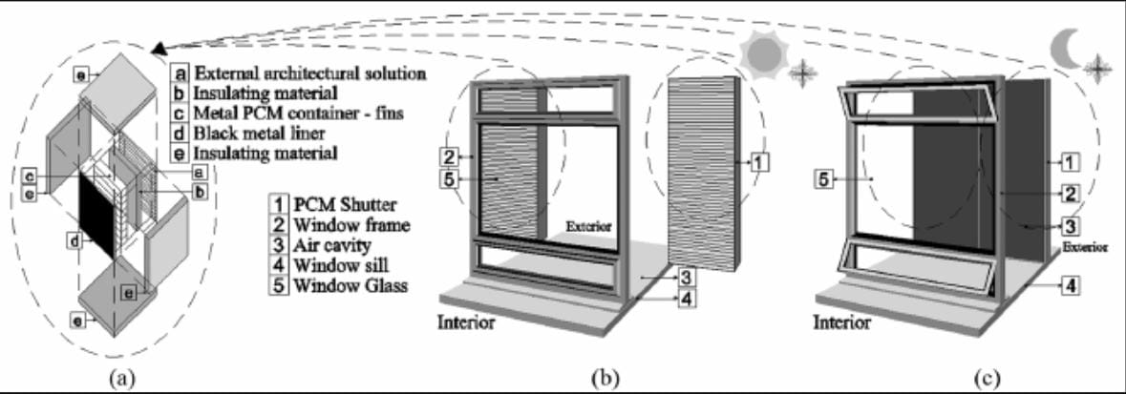
Figure 8. Schematic of PCM shutter storing thermal energy (according to [11])
5.4 Use of PCMs Windows and Glazed Applications
Modern building designs widely use structural elements such as windows, glazed facades and sometimes glazed roofs to provide natural lightning to the room. Considering that the thermal performance of glass material is poor, this indicates the need for the application of PCMs in glass materials. Changyu Liu and colleagues compared air-filled and PCM embedded glass materials. It was observed that the thermal performance of PCM embedded glass materials increased, but the optical properties decreased. One of the most important factors in this regard is the thickness of the glass. Since increasing the thickness reduces transparency and increases thermal properties, it was determined that the thickness should not exceed 16 mm to meet both requirements at the same time. (3)
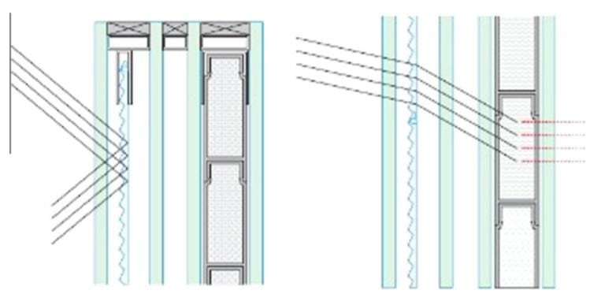
Figure 9. Vertical cross-sectional view of PCM window (according to [10])
Conclusion
Based on the information presented in this literature-based project organic, inorganic, eutectic PCMs are characterized by different temperature ranges for thermal energy storage. Incorporating PCMs into building materials through microencapsulation, macroencapsulation, shape-stabilized methods prevent leakage and is considered safe addition method. PCMs are added to construction materials such as mortar, plaster, concentrate, wall, floor boards to reduce energy consumption in buildings. In general, the use of PCM technology for thermal energy storage and temperature regulation in buildings is considered an effective approach.
References
[1] Rahmatallah Poudineh, Head of Electricity Research, OIES. Global electricity demand: what’s driving growth and why it matters? The Oxford Institute for Energy Studies; 2025.
[2] Energy Efficiency- Energy System. IEA
[3] Christina V.Podara, Ioannis A.Kartsonakis and Costas A.Charitidis. Towards Phase Change Materials for Thermal Energy Storage: Classification, Improvements and Applications in the Building Sector; 2021
[4] Thermal Energy Storage. European Association for Storage of Energy; 2023
[5] Buildings- Energy System. IEA
[6] Zuzana Dicka, Erika Dolnikova and Dusan Katunsky. Phase change materials (PCMs) for building energy efficiency: A review; 2025
[7] What is Phase Change Material? Theory, Example and Applications. Linquip Technews; 2023
[8] Mariaenrica Frigione, Mariateresa Lettieri and Antonella Sarcinella. Phase Change Materials for Energy Efficiency in Buildings and Their Use in Mortars; 2019
[9] D.Zhou, C.Y.Zhao, Y.Tian. Review on thermal energy storage with phase change materials (PCMs) in building applications; 2012
[10] Steinar Grynning, Francesco Goia, Egil Rognvik, Berit Time. Possibilities for Characterization of a PCM Window Sytem Using Large Scale Measurements; 2013
[11] Nelson Soares, J.J.Costa, Antonio Samagaio, Romeu Vicente. Numerical Evaluation of a Phase Change Material-Shutter Using Solar Energy for Winter Nighttime Indoor Heating; 2014
[12] Jose Pereira, Reinaldo Souza, Jeferson Oliveira and Ana Moita. Phase Change Materials in Residential Buildings: Challenges, Opportunities and Performance; 2025
[13] Mohd Hafizal Mohd Isa, Xudong Zhao and Hiroshi Yoshino. Preliminary Study of Passive Cooling Strategy Using a Combination of PCM and Copper Foam to Increase Thermal Heat Storage in Building Facade; 2010
[14] Ziyuan Wang, Wenfu Situ, Xinxi Li, Guoqing Zhang, Zhi Huang, Wangzhou Yuan, Chengzhao Yang, Chuxiong Yang. Novel Shape Stabilized Phase Change Material Based on Epoxy Matrix with Ultrahigh Cycle Life for Thermal Energy Storage;2017
[15] CO2 Emissions- Global Energy Review 2025- Analysis. IEA

